**A PROJECT REPORT ON**

**DRIVER DROWSINESS DETECTION**



**By**

**Princy Upadhyay (1703310139)**

**Lauren Jain (1703310102)**

**Satya Mishra (1703310176)**

**Shriya Goyal (1703310195)**

**Under the Guidance of**

**Dr. Sachi Gupta**



**Department of Computer Science and Engineering**

**Raj Kumar Goel Institute of Technology, Ghaziabad**

**Dr. A.P.J Abdul Kalam Technical University Lucknow**

**July, 2021**

**DRIVER DROWSINESS DETECTION**

By

**Princy Upadhyay (1703310139)**

**Lauren Jain (1703310102)**

**Satya Mishra (1703310176)**

**Shriya Goyal (1703310195)**

Under the Guidance of

**Dr. Sachi Gupta**



Submitted to the Department of Computer Science and Engineering

in partial fulfillment of the requirements for the degree of

Bachelor of Technology in Computer Science and Engineering

**Raj Kumar Goel Institute of Technology, Ghaziabad**

**Dr. A.P.J Abdul Kalam Technical University Lucknow**

**July, 2021**

**DECLARATION**

We hereby declare that this submission is our own work and that, to the best of our knowledge and belief, it contains no material previously published or written by another person nor material which to a substantial extent has been accepted for the award of any other degree or diploma of the university or other institute of higher learning, except where due acknowledgment has been made in the text.

Signature

Princy Upadhyay (1703310139)

Signature

Lauren Jain (1703310102)

Signature

Satya Mishra (1703310176)

Signature

Shriya Goyal (1703310195)

**Approved By:**

**Signature Signature**

**Dr. Lalit Kumar Saraswat Dr Sachi Gupta Project Co-Ordinator HOD**

**CSE Department CSE Department**

**RKGIT, Ghaziabad RKGIT, Ghaziabad**

**CERTIFICATE**

This is to certify that Project Report entitled “Driver Drowsiness Detection” which is submitted by Sudarshan Kumar Prajapati, Stuti Gupta, Sparsh Verma and Shubham Saini in partial fulfillment of the requirement for the award of degree B. Tech. in Department of Computer Science & Engineering of Dr. A. P. J Abdul Kalam Technical University, Lucknow is a record of the candidate own work carried out by him under my supervision. The matter embodied in this report is original and has not been submitted for the award of any other degree.

**Date: Project Guide**

**Name and Signature**

**Dr. Sachi Gupta**

**HOD CSE Department**

**RKGIT, Ghaziabad**

**ACKNOWLEDGEMENT**

It gives us a great sense of pleasure to present the report of the B. Tech Project undertaken during B. Tech. Final Year. We owe special debt of gratitude to Professor Ms. Parul, Department of Computer Science & Engineering, College of Engineering, Lucknow for his constant support and guidance throughout the course of our work. His sincerity, thoroughness and perseverance have been a constant source of inspiration for us. It is only his cognizant efforts that our endeavors have seen light of the day.

We also take the opportunity to acknowledge the contribution of Professor Dr Sachi Gupta, HOD, Department of Computer Science & Engineering, College of Engineering, Lucknow for his full support and assistance during the development of the project.

We also do not like to miss the opportunity to acknowledge the contribution of all faculty members of the department for their kind assistance and cooperation during the development of our project. Last but not the least, we acknowledge our friends for their contribution in the completion of the project.

Signature

Princy Upadhyay (1703310139)

Signature

Lauren Jain (1703310102)

Signature

Satya Mishra (1703310176)

Signature

Shriya Goyal (1703310195)

### 

**ABSTRACT**

Road crashes and related forms of accidents are a common cause of injury and death among the human population. According to data from the World Health Organization, approximately 1.35 million people die each year as a result of road traffic crashes. In India, the number of accidents that has occurred due to driver fatigue has been alarmingly high due to continuous driving, throughout day and night. The effects of drowsiness are similar to alcohol, it will make driving inputs (steering, acceleration, braking) poorer, destroy reaction times and blur the thought processes. Interaction between driver and vehicle such as monitoring and supporting each other is one of the important solutions for keeping ourselves safe in the vehicles. Several deadly accidents can be prevented if the drowsy drivers are warned in time. A direct way of measuring driver fatigue is measuring the state of the driver i.e., drowsiness. So, it is very important to detect the drowsiness of the driver to save life and property. The driver drowsiness detection system will monitor the driver’s eyes using a camera, and by developing an algorithm this project will detect symptoms of driver fatigue early enough to avoid the person from sleeping. So, this project will be helpful in detecting driver fatigue in advance and will give warning output in form of alarm. Though there are several methods for measuring the drowsiness but this approach will be completely non-intrusive which does not affect the driver in any way, hence will give the exact condition of the driver. The relevant features will be extracted from facial expressions such as yawning and eye closure for inferring the level of drowsiness. For implementing this system several OpenCV libraries will be used, this library is based on the real time facial images analysis for warning the driver of drowsiness or in attention to prevent traffic accidents. The facial images of driver will be taken by a web camera. An algorithm and an inference will be proposed to determine the level of fatigue by measuring the eyelid blinking duration and face detection to track the eyes and mouth, and warn the driver accordingly. The strong point of this proposed system will be that the location of the driver will be sent to his / her near and dear one so that in case of any accident with the driver, the person near and dear to him will come to know about the driver on time. Moreover, the warning will be deactivated manually rather than automatically. This will ensure the driver's activation as until he sets off the alarm, the alarm will not go off.

### TABLE OF CONTENTS

### Title…………..………………………………..…….………..........i

### Declaration…..…….………………………….…….………..........ii

### Abstract….………………………….…….…...…..………...........iv

### List of Acronyms……..……………………....…….………...........v

### List of Figure………………..………….…..…….………….........vi

### CHAPTER – 1 INTRODUCTION

### Driver Drowsiness Detection System……...……….…….........1

### 

**LIST OF ACRONYMS**

**LIST OF FIGURES**

Fig.4.1 (Flowchart of Proposed System)…………….………. 10

**CHAPTER – 1**

**INTRODUCTION**

**DRIVER DROWSINESS DETECTION SYSTEM**

Drowsiness or fatigue is one of the main factors that threatens road safety and causes serious injuries, deaths and economic losses. The effects of drowsiness are similar to alcohol - it will impair your driving inputs (steering, acceleration, braking), destroy your reaction time and blur your thought processes. In recent years, the rate of fatal motor vehicle accidents resulting from distracted driving has been increasing. Therefore, there is an urgent need for an alert system to continuously monitor the driver that can alert the driver and reduce the chances of accidents on the roads due to drowsiness problem.

**SIGNS OF DROWSINESS**

There are several signs of drowsiness in the driver -

* Driver may be yawn frequently.
* Driver is unable to keep his eyes open.
* Driver catches him nodding off and has trouble keeping head up.
* The driver's thoughts wander and divert attention from the road.
* The driver can't remember driving the last few miles.

**METHODS TO DETECT DROWSINESS**

Numerous works have been carried out in the field of driver drowsiness monitoring and detection systems using a variety of methods.

There are several different methods used to detect, measure and predict the drowsiness of a driver -

* Subjective methods
* Physiological methods
* Vehicle-based methods
* Behavioral methods
* Hybrid methods

**PRINCIPLE OF PROPOSED SYSTEM**

The principle of the proposed system will be based on the analysis of real-time facial images using the OpenCV library, with a view to warn drivers of drowsiness or to prevent traffic accidents.

But this project will go with Behavioral methods which include -

* Yawning
* Amount of eye closure
* Eye blinking

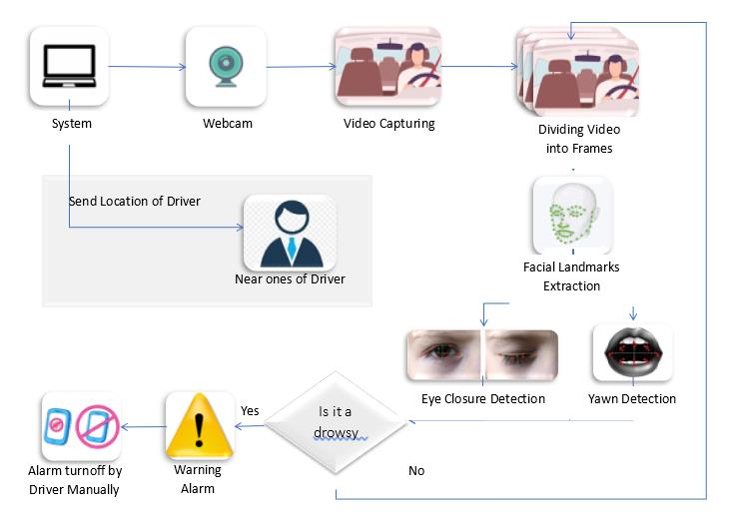

**Fig -1:** Block diagram of Proposed System

The driver's facial images will be taken by a webcam. An algorithm and an inference will be proposed to determine the level of fatigue by measuring the eyelid blinking duration and face detection to track the eyes, mouth and warn the driver accordingly. If the eyes will be found closed or the mouth will be found open for 5 or 8 consecutive frames, then the system will conclude that the driver is asleep and will issue a warning signal.

Detection of fatigue will involve a sequence of images of a face, and the observation of eye movements and blink patterns. Yawning will be included to make the system more precise by determining the movement of the mouth. Once the position of the eyes and mouth will be located, the system will be designed to detect fatigue.

**ADVANTAGES OF PROPOSED SYSTEM**

* The location of the driver will be sent to his / her near and dear one so that in case of any accident with the driver, the person near and dear to him will come to know about the driver on time.
* The alarm warning will be deactivated manually rather than automatically. This will ensure the driver's activation as until he sets off the alarm, the alarm will not go off.

**LITERATURE SURVEY**

**INTRODUCTION**

Drowsy driving means operating a motor vehicle when a person is unable to retain alert due to lack of sleep. Drowsiness or fatigue is one of the main factors that threatens road safety and causes serious injuries, deaths and economic losses. Previous studies showed that the drowsiness level of a driver is related to their facial expression, driving behaviours, and physiological responses.

There are many signs of the driver’s drowsiness –

* Eye blinking
* Frequent yawning
* Difficulty keeping your eyes on the road
* Head nodding
* Irregular speed
* Drifting in and out of your lane
* Daydreaming

Due to the hazards that fatigue create on the roads, researchers have developed various methods to detect driver drowsiness and each technique has its own benefits and limitations.

**LITERATURE REVIEW**

To increase accuracy and accelerate the detection of drowsiness, several approaches have been proposed. This section attempts to summarize previous methods and approaches to drowsiness detection.

* + 1. **EEG-based Drowsiness Detection for Safe Driving Using Chaotic Features and Statistical Tests,** [**Zahra Mardi**](https://www.ncbi.nlm.nih.gov/pubmed/?term=Mardi%20Z%5BAuthor%5D&cauthor=true&cauthor_uid=22606668)**, [Seyedeh Naghmeh Miri Ashtiani](https://www.ncbi.nlm.nih.gov/pubmed/?term=Ashtiani%20SN%5BAuthor%5D&cauthor=true&cauthor_uid=22606668),**[**Mohammad Mikaili**](https://www.ncbi.nlm.nih.gov/pubmed/?term=Mikaili%20M%5BAuthor%5D&cauthor=true&cauthor_uid=22606668)**[1]**

The first class of techniques employs data derived from physiological sensors, such as Electrooculography (EOG), Electrocardiogram (ECG) and Electroencephalogram (EEG) data. EEG signals provide information about the brain’s activity. The three primary signals to measure driver’s drowsiness are theta, delta, and alpha signals. Theta and delta signals spike when a driver is drowsy, while alpha signals rise slightly. According to Mardi et al., this technique is the most accurate method with an accuracy rate of more than 90%. Nevertheless, the main disadvantage of this method is its intrusion. For this, several sensors must be attached to the driver's body, which can be inconvenient. On the other hand, non-intrusive methods are far less accurate for bio-signals.

* + 1. **Steering Wheel Behavior Based Estimation of Fatigue, JarekKrajewski, David Sommer, UdoTrutschel, Dave Edwards, Martin Golz[2]**

The approach already used is based on driving patterns, and is highly dependent on vehicle characteristics, road conditions, and driving skills. To calculate driving pattern, deviation from a lateral or lane position or steering wheel movement should be calculated. While driving, it is necessary to make micro adjustments to the steering wheel to keep the car in one lane. Krajewski et al. detected drowsiness with 86% accuracy on the basis of correlations between micro adjustments and drowsiness. In addition, it is possible to use lane position deviations to identify driving patterns. In this case, the position of the car corresponding to a given lane is monitored, and deviations are analyzed. Nevertheless, techniques based on driving patterns are highly dependent on vehicle characteristics, road conditions, and driving skills.

* + 1. **Driver Drowsiness Detection Model Using Convolutional Neural Networks Techniques for Android Application, RatebJabbar∗†, Mohammed Shinoy∗ , Mohamed Kharbeche∗ , Khalifa Al-Khalifa§ , MoezKrichen‡ , KamelBarkaoui†[3]**

Another technique for detecting a driver's drowsiness is through neural networks. RatebJabbar focuses on the detection of such micro sleep and drowsiness using neural network based methodologies. The author proposed a system in which accuracy was enhanced by using facial landmarks that are detected by the camera and passed to CNN to classify drowsiness. The main achievement of this system is its ability to provide lightweight alternatives to heavy classification models with more than 88% for the category without glasses, more than 85% for the category night without glasses. On average, more than 83% of accuracy was achieved in all categories. Nevertheless, the main limitation of this system is its complexity and intensive computation.

* + 1. **Real Time Eye Detection and Tracking Method for Driver Assistance System, SayaniGhosh, T. Nandy, Nilotpal Manna[4]**

The last category consists of behavioral or computer vision measures that are reliable compared to vehicle-based because they focus on the individual rather than the vehicle. In addition, behavioral measures are non-invasive and more practical than physiological measures. Here, information is obtained using cameras to detect slight changes in the facial expressions of the driver. As behavioral measures are non-invasive in nature, they are becoming a popular method of detecting drowsiness. In this paper, author describes real time eye detection and tracking method that works under variable and realistic lighting conditions. It is based on a hardware system for the real-time acquisition of a driver’s images using IR illuminator and the software implementation for monitoring eye that can avoid the accidents.

**INFERENCES FROM LITERATURE**

**INFERENCES DRAWN OUT OF LITERATURE SURVEY**

Various methods are available to determine the drowsiness status of the driver. But because of the various definitions and the reasons behind them, there is no universally accepted definition for drowsiness, all works discuss different ways in which drowsiness can be manipulated in a simulated environment. Various measures are used to detect drowsiness. These include subjective, vehicle-based, physiological and behavioral measures. The accuracy rate of using physiological measures to detect the drowsiness is high. But these measures are highly intrusive. The intrusive nature can be resolved by using contactless electrode placement.

The following measures are used to detect drowsiness –

**Vehicle Based Measures**

These measurements are determined in a simulated environment by placing sensors on various vehicle components, such as the steering wheel and the acceleration pedal. The signals sent by the sensor are then analyzed to determine the level of drowsiness.

**Parameters –**

**Steering wheel movement**

It is measured using steering angle sensor mounted on the steering column. When the driver is drowsy, the number of micro corrections on the steering wheel reduces compared to normal driving. Drowsy drivers make fewer steering wheel reversals than normal drivers.

**Standard lane deviation**

In field experiments the position of lane is tracked using an external camera. Ingre et al. conducted an experiment to derive numerical statistics based on SDLP and found that, as KSS ratings increased, SDLP (meters) also increased.

**Advantages** - Non intrusive

**Disadvantages**– Unreliable

* + 1. **Physiological Measures**

The correlation between physiological signals electrocardiogram (ECG), Electromyogram (EMG), Electrooculogram (EoG) and electroencephalogram (EEG)) and driver drowsiness has been studied by many researchers. Nevertheless, the main disadvantage of this method is its intrusiveness. It requires many sensors to be attached to the driver's body, which could be uncomfortable. On the other hand, non-intrusive methods for bio-signals are much less precise.

**Advantages**- Reliable, Accurate

**Disadvantages** – Intrusive

* + 1. **Subjective Measures**

Subjective measures are those which evaluate the level of drowsiness based on the driver’s personal estimation. Method used here is questionnaire, commonly used drowsiness scale is the Karolinska Sleepiness Scale (KSS), a nine-point scale that has verbal anchors for each step.

**Advantages** - Subjective

**Disadvantages** - Not possible in real time

* + 1. **Behavioral Measures**

The behaviour of the driver, including yawning, eye closure, eye blinking, head pose, etc., is monitored through a camera and the driver gets alert if any of these drowsiness symptoms are detected.

**Parameters-**

**Yawning**

Compared to speaking, mouth opens widely and is larger in yawning. Yawing can be detected using mouth and face tracking.

**Eye blinking**

In this system the position of irises and eye states are monitored through time to estimate eye blinking frequency and eye close duration. In sleepy state eye blinking and gaze between eyelids are different from normal situations. Using these eyes closure and blinking ratio one can detect drowsiness of driver.

**PERCLOS(the percentage of time that an eye is closed in a given period)**

PERCLOS is an established parameter to detect the level of drowsiness. The PERCLOS score is measured to decide whether the driver is at drowsy state or not.

**Techniques -**

1. **Artificial Neural Network Based technique**

Many of the studies are based on architecture of ANN such as - Multilayer Perceptron (MLP), Back Propagation Neural Networks (BPNN), Retinal Connected Neural Network (RCNN), Rotation Invariant Neural Network (RINN), Fast Neural Networks (FNN), Convolutional Neural Network,and Polynomial Neural Network (PNN). Other studies are based on ANN on combination with other techniques and methods such as Principal Component Analysis with ANN (PCA & ANN), Evolutionary Optimization of Neural Networks, Gabor Wavelet Faces with ANN, and finally Skin Color and BPNN.

Most of the studies of face detection systems have adopted ANN in combination with other approaches and algorithms to obtain better results for detection and improve the performance of face detection system. But this may increase the system complexity, required memory and time for face detection.

**Advantages** - Reliable, Accurate

**Disadvantages** - Computation intensive

1. **Template Matching Technique**

In this, one can use the states of eyes (images at different intervals) i.e. if driver closes eye/s for some particular time then system will give an alert.

**Advantages**- Nonintrusive, Ease of use

**Disadvantages** - Lighting condition Background

**PROBLEM STATEMENT AND SOLUTION APPROACH**

**PROBLEM STATEMENT**

Designing a prototype drowsiness detection system that will focus on continuously and accurately monitoring the position of the driver's eyes and mouth in real time and check if they are open or closed for more than the given period of time.

**PROPOSED WORK**

**The objectives of the project for the proposed work are -**

* Introduce novel approach to prevent driver drowsiness.
* Take video as input from webcam and convert it to frame.
* Accurately measure all the features to detect drowsiness like –

Facial Landmark Detection.

Eye and Mouth Detection.

Eye Aspect Ratio

Yawn Detection

* Share location to near and dear person.

**The strong point of this proposed system is that –**

* The location of the driver will be sent to his / her near and dear one so that in case of any accident with the driver, the person near and dear to him will come to know about the driver on time.
* The alarm warning will be deactivated manually rather than automatically. This will ensure the driver's activation as until he sets off the alarm, the alarm will not go off.

**Source Code :**

**from** django.shortcuts **import** render  
**import** time  
**import** cv2  
**import** dlib  
**import** threading  
**from** imutils **import** face_utils  
**from** scipy.spatial **import** distance **as** dist  
**import** pygame  
  
  
*# Eye Aspect Ratio Calculation***def** eye_aspect_ratio(eye):  
 A = dist.euclidean(eye[1], eye[5])  
 B = dist.euclidean(eye[2], eye[4])  
 C = dist.euclidean(eye[0], eye[3])  
 ear = (A + B) / (2.0 * C)  
 **return** ear  
  
  
*# Mouth Aspect Ratio Calculation***def** mouth_aspect_ratio(mouth):  
 A = dist.euclidean(mouth[13], mouth[19])  
 B = dist.euclidean(mouth[14], mouth[18])  
 C = dist.euclidean(mouth[15], mouth[17])  
  
 MAR = (A + B + C) / 3.0  
 **return** MAR  
  
  
*# Loading sound alarm***def** sound_alarm():  
 pygame.mixer.init()  
 pygame.mixer.music.load(**"sound files_alarm.mp3"**)  
 pygame.mixer.music.play()  
  
  
*# Starting the application***def** start(request):  
 MAR_THRESHOLD = 14  
 EYE_AR_THRESH = 0.3  
 EYE_AR_CONSEC_FRAMES = 30  
  
 COUNTER_EYE = 0  
 COUNTER_YAWN = 0  
 TOTAL_EYE = 0  
 TOTAL_YAWN = 0  
  
 ALARM_ON = **False** videoSteam = cv2.VideoCapture(0)  
 ret, frame = videoSteam.read()  
 size = frame.shape  
  
 detector = dlib.get_frontal_face_detector()  
 predictor = dlib.shape_predictor(**"shape_predictor_68_face_landmarks.dat"**)  
 (lStart, lEnd) = face_utils.FACIAL_LANDMARKS_IDXS[**"left_eye"**]  
 (rStart, rEnd) = face_utils.FACIAL_LANDMARKS_IDXS[**"right_eye"**]  
 (mstart, mend) = face_utils.FACIAL_LANDMARKS_IDXS[**"mouth"**]  
  
 t_end = time.time()  
  
 **while True**:  
  
 ret, frame = videoSteam.read()  
 gray = cv2.cvtColor(frame, cv2.COLOR_BGR2GRAY)  
 rects = detector(gray, 0)  
  
 **for** rect **in** rects:  
  
 shape = predictor(gray, rect)  
 shape = face_utils.shape_to_np(shape)  
  
 leftEye = shape[lStart:lEnd]  
 rightEye = shape[rStart:rEnd]  
 mouth = shape[mstart:mend]  
 leftEAR = eye_aspect_ratio(leftEye)  
 rightEAR = eye_aspect_ratio(rightEye)  
  
 ear = (leftEAR + rightEAR) / 2.0  
  
 leftEyeHull = cv2.convexHull(leftEye)  
 rightEyeHull = cv2.convexHull(rightEye)  
  
 MAR = mouth_aspect_ratio(mouth)  
 cv2.drawContours(frame, [leftEyeHull], -1, (255, 255, 0), 1)  
 cv2.drawContours(frame, [rightEyeHull], -1, (255, 255, 0), 1)  
 cv2.drawContours(frame, [mouth], -1, (255, 255, 0), 1)  
  
 *# Count number of blinks* **if** ear < EYE_AR_THRESH:  
 COUNTER_EYE += 1  
 *# If eye reamin close for 90 or more consecutive frames i.e. for approx. 5 seconds or more then alert signal is sent* **if** COUNTER_EYE >= 3 * EYE_AR_CONSEC_FRAMES:  
 **if not** ALARM_ON:  
 ALARM_ON = **True** d = threading.Thread(target=sound_alarm)  
 d.setDaemon(**True**)  
 d.start()  
 key = cv2.waitKey(1) & 0xFF  
 **if** key == ord(**"s"**):  
 **if** ALARM_ON:  
 pygame.mixer.music.quit()  
 cv2.putText(frame, **"Send Alert!"**, (200, 60), cv2.FONT_HERSHEY_SIMPLEX, 1.0, (255, 0, 255), 2)  
 **else**:  
 **if** COUNTER_EYE >= EYE_AR_CONSEC_FRAMES:  
 TOTAL_EYE += 1  
  
 COUNTER_EYE = 0  
  
 *# Count number of yawn* **if** MAR > MAR_THRESHOLD:  
 COUNTER_YAWN += 1  
 cv2.drawContours(frame, [mouth], -1, (255, 255, 0), 1)  
 **else**:  
 **if** COUNTER_YAWN >= EYE_AR_CONSEC_FRAMES:  
 TOTAL_YAWN += 1  
  
 COUNTER_YAWN = 0  
  
 *# Condition to detect drowsiness based on number of blinks and number of yawn* **if** TOTAL_EYE >= 2 **and** TOTAL_YAWN >= 1:  
 **if not** ALARM_ON:  
 ALARM_ON = **True** d = threading.Thread(target=sound_alarm)  
 d.setDaemon(**True**)  
 d.start()  
 key = cv2.waitKey(1) & 0xFF  
 **if** key == ord(**"s"**):  
 **if** ALARM_ON:  
 pygame.mixer.music.quit()  
 cv2.putText(frame, **"Send Alert!"**, (200, 60), cv2.FONT_HERSHEY_SIMPLEX, 1.0, (255, 0, 255), 2)  
  
 *# Condition to detect drowsiness based on number of blinks* **elif** TOTAL_EYE >= 3:  
 **if not** ALARM_ON:  
 ALARM_ON = **True** d = threading.Thread(target=sound_alarm)  
 d.setDaemon(**True**)  
 d.start()  
 key = cv2.waitKey(1) & 0xFF  
 **if** key == ord(**"s"**):  
 **if** ALARM_ON:  
 pygame.mixer.music.quit()  
 cv2.putText(frame, **"Send Alert!"**, (200, 60), cv2.FONT_HERSHEY_SIMPLEX, 1.0, (255, 0, 255), 2)  
  
 *# Condition to detect drowsiness based on number of yawn* **elif** TOTAL_YAWN >= 2:  
 **if not** ALARM_ON:  
 ALARM_ON = **True** d = threading.Thread(target=sound_alarm)  
 d.setDaemon(**True**)  
 d.start()  
 key = cv2.waitKey(1) & 0xFF  
 **if** key == ord(**"s"**):  
 **if** ALARM_ON:  
 pygame.mixer.music.quit()  
 cv2.putText(frame, **"Send Alert!"**, (200, 60), cv2.FONT_HERSHEY_SIMPLEX, 1.0, (255, 0, 255), 2)  
  
 cv2.putText(  
 frame,  
 **"Blinks: {}"**.format(TOTAL_EYE),  
 (30, 30),  
 cv2.FONT_HERSHEY_SIMPLEX,  
 0.7,  
 (0, 0, 255),  
 2,  
 )  
 cv2.putText(  
 frame,  
 **"EAR: {:.2f}"**.format(ear),  
 (30, 70),  
 cv2.FONT_HERSHEY_SIMPLEX,  
 0.7,  
 (0, 0, 255),  
 2,  
 )  
 cv2.putText(  
 frame,  
 **"Yawn: {}"**.format(TOTAL_YAWN),  
 (430, 30),  
 cv2.FONT_HERSHEY_SIMPLEX,  
 0.7,  
 (0, 0, 255),  
 2,  
 )  
 cv2.putText(  
 frame,  
 **"MAR: {:.2f}"**.format(MAR),  
 (430, 70),  
 cv2.FONT_HERSHEY_SIMPLEX,  
 0.7,  
 (0, 0, 255),  
 2,  
 )  
 cv2.putText(frame, **"Press q for exit"**, (30, 400), cv2.FONT_HERSHEY_SIMPLEX, 0.9, (0, 255, 255), 2)  
  
 cv2.imshow(**"Frame"**, frame)  
 key = cv2.waitKey(1) & 0xFF  
  
 **if** key == ord(**"q"**):  
 **break** cv2.destroyAllWindows()  
 videoSteam.release()  
  
 **return** render(request, **'index.html'**)

**CHAPTER -2**

**METHODOLOGY**

The principle challenge for identifying drowsiness is to determine fatigue by facial expression and to measure it. To do this, the system detects drowsiness in real time by observing the driver’s eyes and mouth. The driver face monitoring system checks the actual condition of the driver based on the processing of the driver's face image. Driver's exhaustion status is identified from eyelids closure, eye blinking, the distance between eyelids, and yawning in this proposed system. Furthermore, if the driver gets tired, the system produces an alarm until the driver becomes alert and recaptures awareness. The stages of the proposed system are described in Fig -2 through a flowchart.

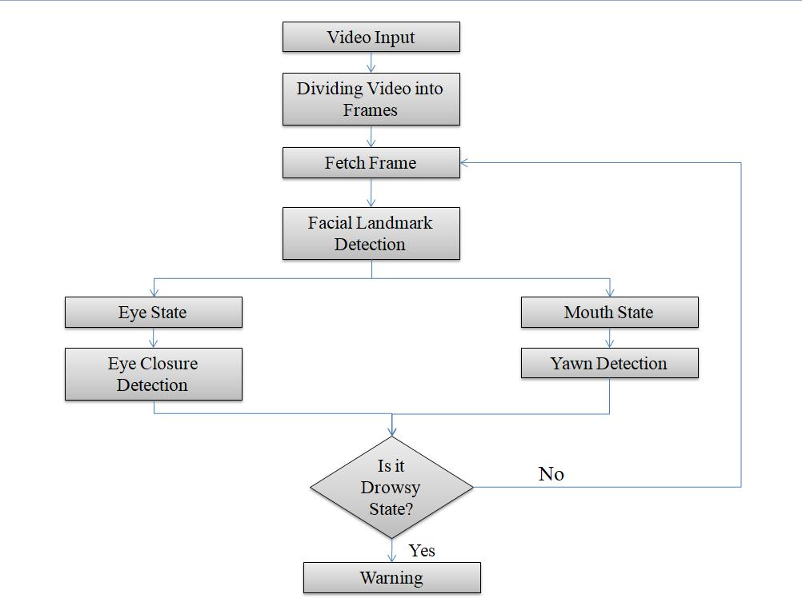

**Fig -2: Flowchart of Proposed System**

As a first step, the real time video is taken as an input and then the footage is separated up into multiple frames, each of which is then processed further. In second step, the system locates facial landmarks from the frame. And then features are extracted from facial components and landmarks. The proposed system is able to detect the facial features at different angles and also in dim light as shown in Fig -3.

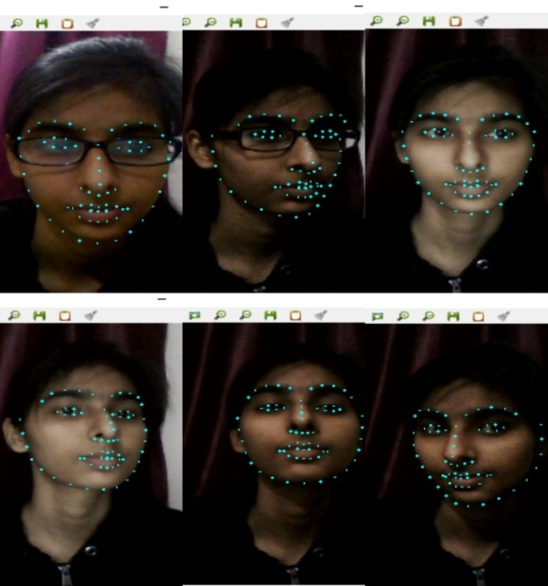

**Fig -3: Facial Landmark Detection**

After the localization of the driver’s facial features, the next challenge is to find out the state of eyes and mouth. The blinking ratio is then determined. In case of blink detection, 30 consecutive frames are observed and if the eyes are found closed in those frames then the system count it as a blink and after 3 blinks it gives a warning alarm and if the eyes of the driver are found closed for more than 90 frames then also it generates a warning alarm.

Detection of eye state is not a sufficient factor to determine fatigue and drowsiness, yawing detection is also an essential feature for this. In the yawning position, the mouth becomes wider and the geometric features of the mouth change. When the mouth begins to open, the value of the threshold pixel increases compared to the normal state of the mouth, which is yawning.

In case of yawning, 30 consecutive frames are observed and if mouth is found open in those frames then the system count it as a yawn and after 2 yawn it gives a warning alarm. The implementation of blink and yawn detection is shown in Fig -4. If one or both of the two conditions occur (eyes closed and yawing), the system defines it as a state of drowsiness and a warning alarm is turned on and it remains on until the driver would have come in a normal state. If the system does not find the driver in drowsy state then it continues to receive frames and perform further processing.

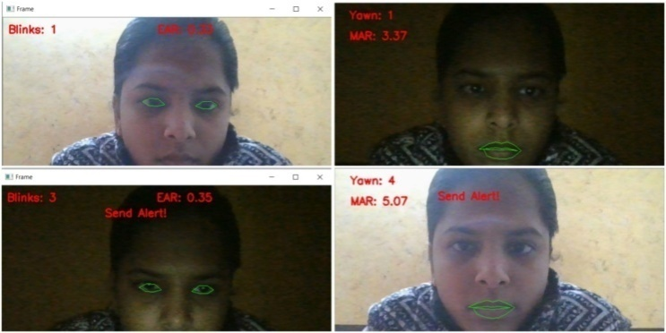

**Fig -4: Blink and Yawn Detection**

1. **Algorithm**
2. **Analysis of Eye Aspect Ratio-**

Each eye is consists of 6(x,y) coordinates landmarks returned by the dlib predictor function, starting from the left corner of the eye and then work towards the right corner by working around the remainder of the region. There is a connection between the width and the height of these coordinates and this relation is expressed by Eye Aspect Ratio (EAR).

$$Eye Aspect Ratio=\frac{\left|p2-p6\right|+|p3-p5|}{2|p1-p4|}$$

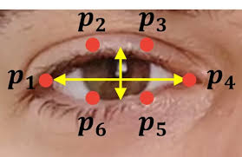

**Fig -5: Eye Aspect Ratio Calculation**

1. **Analysis of Mouth Aspect Ratio –**

Each eye consists of 20(x,y) coordinates landmarks returned by the dlib predictor function, starting from the left corner of the eye and then work towards the right corner by working around the remainder of the region. There is a connection between the width and the height of these coordinates and this relation is expressed by Mouth Aspect Ratio (MAR).

$$Mouth Aspect Ratio=\frac{\left|C-D\right|+\left|E-F\right|+|G-H|}{3.0}$$

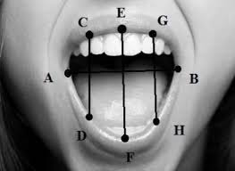

**Fig -6 Mouth Aspect Ratio Calculation**

1. **COMPARISON OF VARIOUS METHODOLOGIES**

To increase accuracy and speed up the detection of drowsiness, a few methodologies have been proposed. This part endeavors to investigate past techniques for identifying drowsiness and compares past methodologies with the proposed approach.

## Physiological Method

This class of methods utilizes information got from the physiological sensors, for example Electrocardiogram (ECG), Electroencephalogram (EEG) and Electrooculography (EOG) information [4]. EEG indicators give data about the operations of the brain. Theta, delta, and alpha signals are the three most important indicators of a driver's drowsiness. When a driver is lethargic, theta and delta signals increase, whereas alpha signals rise marginally. This methodology is the most precise method with precision rate of more than 90% [4]. The biggest con of this method, however, is its intrusion. This necessitates the placement of multiple sensors on the person’s body, which can be cumbersome. Non-intrusive approaches, on the other side, are far less accurate than bio-signals.

## Subjective Method

Subjective methods are those which evaluate the degree of drowsiness by the driver's own assessment [8]. The method used here is a questionnaire, and the Karolinska Sleepiness Scale (KSS), a 9-point scale with verbal anchors for each step, is commonly used [9]. Yet, the principle impediment of this technique is that it is unrealistic.

## Vehicle based Method

These estimates are derived from a simulated environment by the installation of sensors across different sections of vehicle, for example, the control wheel and the accelerator pedal [5]. The indications sent by the sensor are then analyzed to determine the level of sleepiness. Yet, methods dependent on driving examples are profoundly reliant on vehicle attributes, street environment, and driving capabilities. Hence, this methodology is inconsistent.

## Behavioral Method

In this methodology, the behavior of the person driving the vehicle including eye closing, eye blinking, yawning are observed through a webcam and the person driving the vehicle gets alert signal if any of these sleepiness symptoms are detected [7]. And this approach is reliable compared to vehicle-based approach because it centers on the individual as opposed to the vehicle. Also, behavioral measures are unobtrusive and more reliable than physiological measures.

The pros and cons of different types of measures are expressed in Table -1 [10].

**Table - 1: Comparison of Different Measures**

|  |  |  |  |
| --- | --- | --- | --- |
| Measures | Parameters | Advantages | Disadvantages |
| Physiological measures | Information derived from the physiological sensors | Reliable, Accurate | Intrusive |
| Subjective measures | Questionnaire | Subjective | Unrealistic |
| Vehicle based measures | Steering wheel movement, Standard Lane deviation | Non-intrusive | Unreliable |
| Behavioral measures | Eye closure, yawn | Non-intrusive, Ease of use | Lighting condition background |

**CHAPTER-3**

**RESULTS**

The driver can start the system by pressing the START button in the User Interface (UI) which turns on the webcam of the driver’s device and start to monitor his face. The User Interface (UI) of the system looks like as shown in Fig -5.

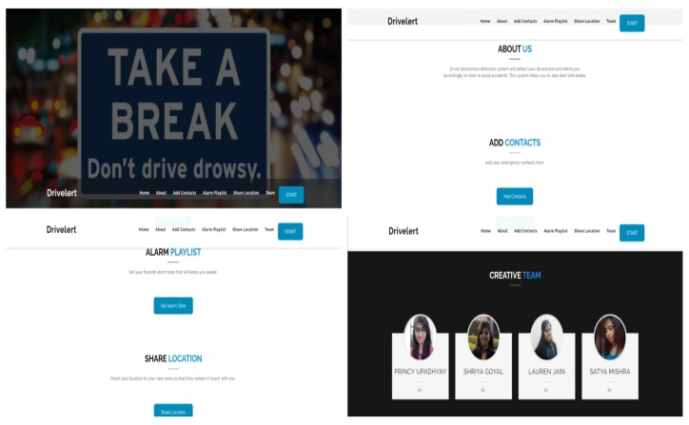

**Fig -7: User Interface**

Based on the number of blinks and yawn the system generates the alarm signal. The demo of the alarm generation based on 2 eye blinks and 1 yawn is shown in Fig -8.

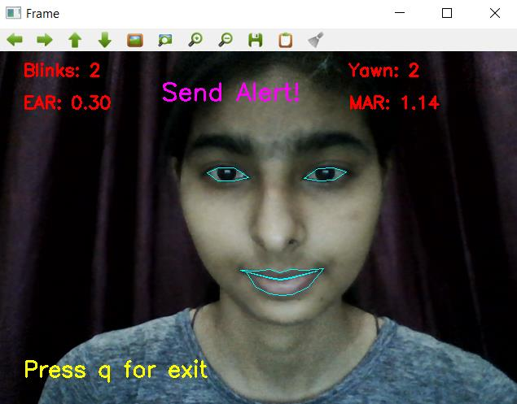

**Fig -8: Result of Proposed System**

**CHAPTER-4**

**CONCLUSION**

In this paper various methods are reviewed for detecting drowsiness of driver. Subjective, vehicle-based, physical, and behavioral metrics have all been examined [2], with the benefits and drawbacks of each highlighted. The proposed system involves analyzing the facial expression taken by the camera to detect eye blink and yawning. The various motions of the eyes and mouth (such as opening and closing) help detect the level of drowsiness of the driver, which are used to generate warning alarms.

In the proposed system, the driver's drowsiness is detected by analyzing the real-time image taken by the camera using the OpenCV library.

The system involves various steps –

1. The face detection using OpenCV library.
2. Detection of the eye and mouth using dlib library.
3. Detection of the level of drowsiness of driver by calculating Eye Aspect Ratio (EAR) and Mouth Aspect Ratio (MAR).
4. Generation of warning alarm according to EAR and MAR values.

**REFERENCES**

* Younes Ed-Doughmi1,* , NajlaeIdrissi 1, Youssef Hbali 2: Real-Time System for Driver Fatigue Detection Based on a Recurrent Neuronal Network(2020)
* Taranpreet Kaur, Sanjay Kumar Singh: Enhance the Driver Drowsiness Detection System Using EDAMAS and Region Prop Techniques(2014)
* [Muhammad Awais](https://pubmed.ncbi.nlm.nih.gov/?term=Awais+M&cauthor_id=28858220) [1](https://pubmed.ncbi.nlm.nih.gov/28858220/#affiliation-1) [2](https://pubmed.ncbi.nlm.nih.gov/28858220/#affiliation-2), [Nasreen Badruddin](https://pubmed.ncbi.nlm.nih.gov/?term=Badruddin+N&cauthor_id=28858220) [3](https://pubmed.ncbi.nlm.nih.gov/28858220/#affiliation-3) [4](https://pubmed.ncbi.nlm.nih.gov/28858220/#affiliation-4), [Micheal Drieberg](https://pubmed.ncbi.nlm.nih.gov/?term=Drieberg+M&cauthor_id=28858220) [5](https://pubmed.ncbi.nlm.nih.gov/28858220/#affiliation-5): A Hybrid Approach to Detect Driver Drowsiness Utilizing Physiological Signals to Improve System Performance and Wearability(2017)
* Zahra Mardi, Seyedeh Naghmeh Miri Ashtiani, Mohammad Mikaili: EEG-based Drowsiness Detection for Safe Driving Using Chaotic Features and Statistical Tests(2011)
* Jarek Krajewski, David Sommer, Udo Trutschel, Dave Edwards, Martin Golz: Steering Wheel Behavior Based Estimation of Fatigue(2009)
* RatebJabbar, Mohammed Shinoy , Mohamed Kharbeche, Khalifa Al-Khalifa, Moez Krichen, Kamel Barkaoui: Driver Drowsiness Detection Model Using Convolutional Neural Networks Techniques for Android Application(2020)
* Sayani Ghosh, T. Nandy, Nilotpal Manna: Real Time Eye Detection and Tracking Method for Driver Assistance System(2015)
* Alina Mashko: Subjective Methods For Assessment Of Driver Drowsiness(2017)
* [Arun Sahayadhas](https://pubmed.ncbi.nlm.nih.gov/?term=Sahayadhas+A&cauthor_id=23719977)[1](https://pubmed.ncbi.nlm.nih.gov/23719977/#affiliation-1), [Kenneth Sundaraj](https://pubmed.ncbi.nlm.nih.gov/?term=Sundaraj+K&cauthor_id=23719977), [Murugappan Murugappan](https://pubmed.ncbi.nlm.nih.gov/?term=Murugappan+M&cauthor_id=23719977): Drowsiness detection during different times of day using multiple features(2013)

* [Arun Sahayadhas](https://www.ncbi.nlm.nih.gov/pubmed/?term=Sahayadhas%20A%5BAuthor%5D&cauthor=true&cauthor_uid=23223151),* [Kenneth Sundaraj](https://www.ncbi.nlm.nih.gov/pubmed/?term=Sundaraj%20K%5BAuthor%5D&cauthor=true&cauthor_uid=23223151), [Murugappan Murugappan](https://www.ncbi.nlm.nih.gov/pubmed/?term=Murugappan%20M%5BAuthor%5D&cauthor=true&cauthor_uid=23223151): Detecting Driver Drowsiness Based on Sensors(2012)

Appendix